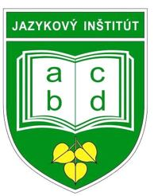 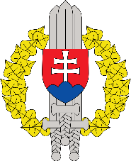

**International English Language Conference**

**Liptovský Mikuláš, SLOVAKIA**

**DRAFT Conference Program**

**3 – 5 June, 2024**

**“AT EASE 2024”**

**DRAFT PROGRAM**

|  |  |  |  |  |
| --- | --- | --- | --- | --- |
| **Time** | **Activity** | | **Location** | **Dress code** |
| **Sunday 2 June 2024** | | | | |
| All day | Arrival | | | |
| 19.00-21.00 | Welcome Reception | | TBC | Smart casual |
| **Monday 3 June 2024** | | | | |
| 08.30-09.30 | Registration | | Military Academy | Relaxed  Business |
| 09.30-10.00 | Welcome address:  Host nation senior representative | |
| 10.00-10.15 | Host nation presentation | |
| 10.15-11.00 | Coffee Break/Group photo | |
| 11.00-12.30 | Presentations/Plenaries/Workshops | |
| 12.30-14.00 | Lunch (Military academy) | |
| 14.00-15.30 | Presentations/Plenaries/Workshops | |
| 15.30-16.00 | Coffee Break | |
| 17.00-20.00 | Guided tour / Cultural evening | | Liptovský Mikuláš | Smart casual |
| **Tuesday 04 June 2024** | | | | |
| 09.00-10.30 | Presentations/Plenaries/Workshops | Military Academy | | Relaxed  Business |
| 10.30-11.00 | Coffee Break |
| 11.00-12.30 | Presentations/Plenaries/Workshops |
| 12.30-13.30 | Lunch |
| 13.30-14.30 | Presentations/Plenaries/Workshops |
| 14.30-15.00 | Coffee Break |
| 15.00-16.00 | Presentations/Plenaries/Workshops |
| 17.00-20.00 | Free evening / Cultural evening (based on interest) | TBC | | Smart casual |
| **Wednesday 05 June 2024** | | | | |
| 09.00-10.30 | Presentations/Plenaries/Workshops | Military Academy | | Relaxed  Business |
| 10.30-11.00 | Coffee Break |
| 11.00-12.00 | Presentations/Plenaries/Workshops |
| 12.00-13.00 | Host nation lunch |
| 13.00-13.30 | Wrap-up activities, Closing remarks |
| 13.30 | End of conference |

**We particularly encourage you to participate in this new event with your contributions in PRESENTATIONS / DIGITAL POSTERS / WORKSHOPS. Without them we can't have the succesfull Conference.**

Note: The Conference venue is the Slovak Armed Force Language institute.

It is customary for military personnel to wear civilian dress during the Conference.